**Colleague (Support Staff and Fellow Consultants) Assessment 2024**

**Dr Anthony W Nathan**

**Listed by GMC Good Medical Practice (GMP) Domains**

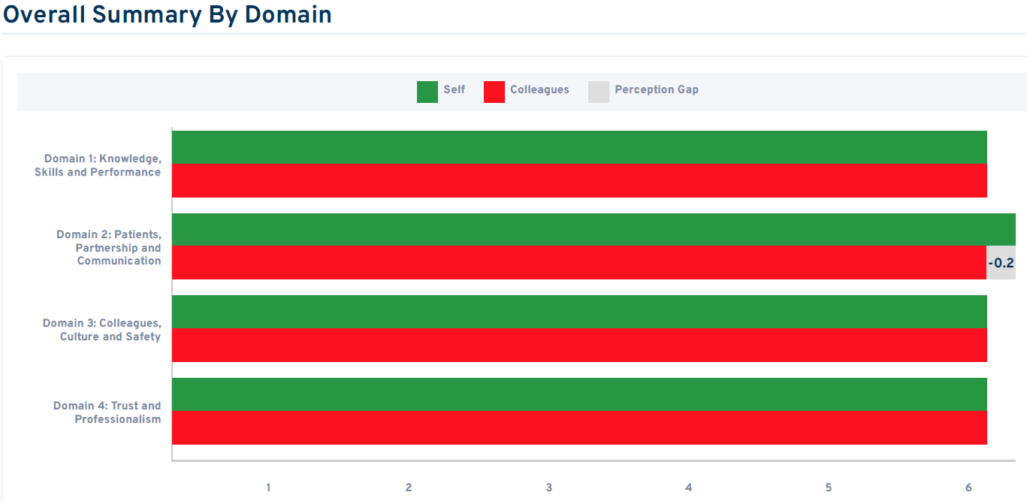

**Overall Summary Comments**

**Domain 1: Knowledge, Skills and Performance**

Purple = Support staff, Blue = Peers – ie other doctors

Purple = Support staff, Blue = Peers – ie other doctors

Purple = Support staff, Blue = Peers – ie other doctors

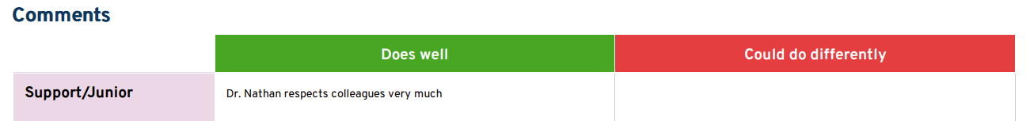 Purple = Support staff, Blue = Peers – ie other doctors

